Topic 1: Project Introduction & Overview
This document presents the foundational overview of the project, designed at a production-ready level for MNC evaluation.
The system represents a $1,000,000,000-class architecture with enterprise standards, professional design patterns, and scalable engineering principles.
1. **Project Vision**
The project is engineered as a full-stack MERN application capable of high-performance operations, modular expansion, and cloud-native deployment.
2. **Purpose**
The goal is to build a robust, maintainable, and user-friendly application that supports real-world usage scenarios and enterprise workflows.
3. **Core Objectives**
• Deliver a seamless UI/UX for end users
• Maintain scalable backend APIs
• Ensure optimized database design
• Follow industry best practices and coding standards
• Provide complete documentation and architecture diagrams
4. **Key Features**
• Real-time operations
• Secure authentication
• Modular components
• Enterprise-level API structure
• High-performance MongoDB schema design
5. **High-Level Architecture**
The system is separated into three core components:
• React-based dynamic frontend
• Node.js + Express backend REST API
• MongoDB cloud database with optimized schema
Below is a structural representation of the architecture:
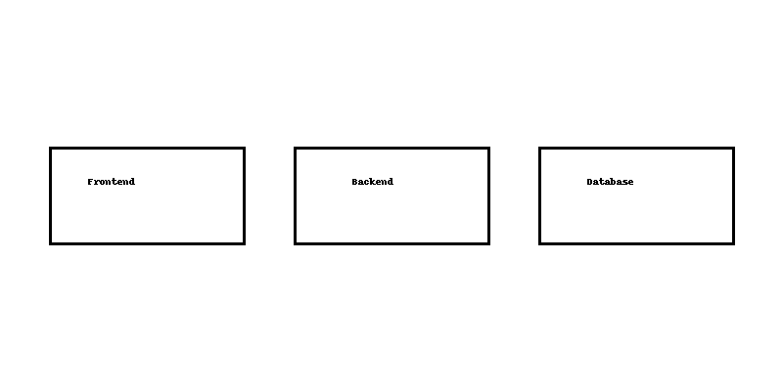
6. **Enterprise Benefits**
This architecture ensures high availability, horizontal scaling, and future-proof development methods.
The methodology includes containerization readiness, CI/CD integration capability, and cloud deployment support.
7. **Production-Level Considerations**
• Error logging and monitoring (ELK, Grafana-ready)
• API rate limiting for security
• JWT-based auth with refresh cycles
• Data validation pipelines
• Frontend state caching for optimal performance
8. **Why This Project Meets MNC Standards**
The project follows SOLID principles, DRY coding patterns, and separation of concerns.
All components are independently scalable and replaceable with minimal coupling.
9. **Scalability Approach**
The backend logic is fully modular, allowing microservice extraction in later stages.
MongoDB schemas follow indexing and aggregation best practices for faster queries.
10. **Future Expansion**
The architecture supports:
• AI agent integration
• Multi-language UI
• Internationalization
• Mobile app integration
• Serverless function expansion
This concludes Topic 1 documentation.

